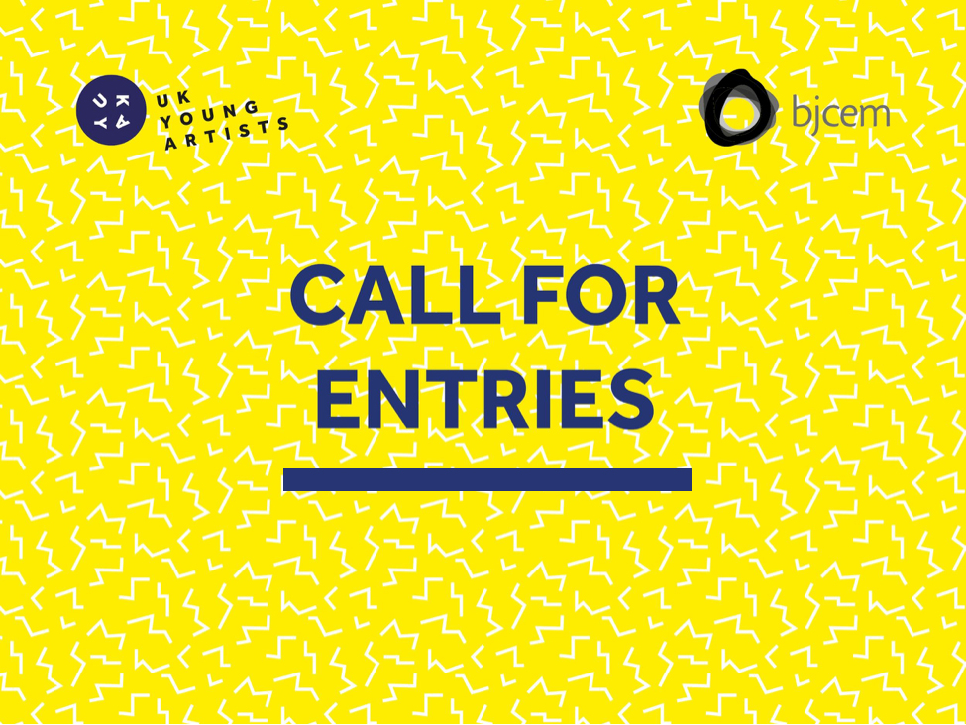



In collaborazione con

**UKYA CITY TAKEOVER: NOTTINGHAM 2019  
200 ARTISTS. 3 CONTINENTS. 150 EVENTS. 7 DAYS  
07 - 13 FEB 2019  
  
UKYA City Takeover: Nottingham 2019** will span the city, immersing visitors in an array of extraordinary, innovative and contemporary work from over 200 artists from three continents. Visual arts, performance, music and words will animate cultural spaces and unusual places across Nottingham.

The UKYA City Takeover: Nottingham 2019 promises to be provocative, exciting, discerning and unique. Presenting art across borders, countries and nationalities; taking risks and opening minds.Thank you for your interest in applying for UKYA City Takeover.   
Please complete all parts of this application form, including the dropbox link to your supporting media.

***SECTION 1 - ABOUT YOU:***

**First Name**:  
**Last Name**:

**Are you applying as an individual or on behalf of a group?** *please delete as appropriate*

An individual  A group

**Group Name***if applicable*:

**Address**:  
**Post code**:

**Email Address**:  
**Confirm email address:**

**Website***if applicable*: http://

**Nationality**:

**Date of birth**: *Please note that the eligibility criteria of BJCEM specifies that you must be aged 18-35 to apply for any opportunities.*

**If applying as part of a collective is at least 75% of your group be aged between 18 and 35 on 01 July 2018?**

Yes  No  I'm not applying as part of a group

**SECTION 2. YOU AND YOUR WORK***Your answers will form part of our selection process*

|  |
| --- |
| **Artist/Company Biography** *up to 100 words**If you are successful in your application, the information provided in this section will be used in full or in part within printed publicity materials and on the UK Young Artists and BJCEM websites. They will also form part of the content of press releases sent out about the City Takeover. Therefore you should be happy for the information you provide to be made public. See UK Young Artists website article ‘Best Foot Forward’ for guidance and advice.  Please write here...* |

|  |
| --- |
| **Taking part:** up to*200 words* *UK Young Artists & BJCEM are about both exceptional art and creating a space for dialogue and intercultural exchange between young artists. As well as showcasing your work in the City Takeover, you will be able to meet 200 artists from across the globe and participate in workshops, talks and symposia. We are looking for artists that demonstrate an original voice within their work, who demonstrate an appetite to develop their work or practice and that BJCEM & UKYA are able to see how they are able to support the practice and development of selected artists through our work*  *This information will not be used in public promotions and materials. This statement should cover:*   * *How you think your work would benefit from being part of this event* * *Your interest in connecting and collaborating with artists from other disciplines*   *Please write here…* |

**Which category best describes the work you are submitting?**

**Applied Art:** ceramics, glass, textiles, jewellery, fashion, printmaking, architecture

**Design:** graphic and product design

**Digital Art:** animation, projection mapping, mixed reality performance, virtual reality, game design, interactive art and installation.

**Literature:** writing, poetry, storytelling and spoken word.

**Moving Image:** film, documentary, artist video and animation.

**Music:** sound art and all genres of music will be considered from individuals, bands and collaborations.

**Performance:** theatre, dance, live art, site-specific and outdoor performance.

**Visual Arts:** fine art, photography, installation, illustration, site-specific work and sculpture.

**SECTION 3. ART FORM SPECIFIC QUESTIONS***These questions are designed to provide information about a range of art forms. Please answer all questions that are applicable to your work. If a question is not applicable to your work, please indicate this in the box by typing N/A.*

**Title of work:**

|  |
| --- |
| **Description of work** *(up to 300 words) If you are successful in your application, the information provided in this section will be used in full or in part within printed publicity materials and on the UK Young Artists & BJCEM websites. They will also form part of the content of press releases sent out about the City Takeover. Therefore you should be happy for the information you provide to be made public.*  *Please write here...* |

**Year created:**

**Number of works in the series** (if applicable):

**Material/medium (e.g. paint, photography, theatre, dance, live art)**:

**Average set times (music)**:

**Genre (music):**

**Dimensions (if applicable):**

**Weight (if applicable):**

**Format (moving image)**:

**Presentation style/requirements:**

**Number of performers:**

**Running time (if applicable):**

**Equipment needed to present work:**

**Do you have access to this equipment?:**

**Site specific work**  
*If you wish to present your work in a non-traditional space please give a brief outline here of the type of venue you would to work in:*

**Creative presentation of work**  
*We are open to creative ways of presenting writing across the festival venues, if you have any ideas of how your work could be viewed please describe them here. Previous events have included work printed onto café menus and informal recitals in library spaces*.

*Please write here...*

|  |
| --- |
| **Concepts & themes of work** *up to 150 words This information* ***will not*** *be used in public materials and is your chance to tell the panel any further relevant information about the work you’re submitting, if you would like to.*  *Please write here...* |

**SUPPORTING DOCUMENTATION**

|  |
| --- |
| **Dropbox Link:** |

Please provide a link to a Dropbox folder containing the following:

**Your CV***(max. two sides of A4) in PDF format only and titled ‘firstname_lastname_cv’.*

**For visual arts:***Up to five images or videos of the work you are applying with. If successful in your application, these images will be used in press and promotional materials for the City Takeover, and across UKYA’s digital channels.*

**For literature:***Up to four examples of your written work, with a maximum of 500 words per example.* If your works are not in english, please be sure to include abstracts in english.

**For performance and moving image:**For video and performance work, you may submit up to four minutes of actual footage from your work. If successful in your application, some of these clips might be used in trailers for the City Takeover.Please make sure that the video you provide satisfies these criteria:

* *Clearly audible where there is sound*
* *Clear and high quality video. Don’t submit video that is dark and blurry as the panel will not be able to properly see the work*
* *If you have footage of an entire performance, select snippets of the video and create a trailer/showreel that allows the panel to get a sense of the work in a short space of time*
* *Equally, if you are submitting screen based work (moving image, animation etc), editing a trailer or highlights reel is an effective way to communicate the quality of your work in a short space of time*
* *Make sure that the video file is in an accessible format, for example MP4 or MOV, so that the panel can open it. If you are submitting a vimeo or YouTube link, make sure the video is publicly accessible or UKYA has been given the necessary access/passwords*

**For music:***Artists submitting work across music and sound art can submit up to four minutes of audio files, which can be across up to four separate tracks.*

**Applications without supporting documentation will not be considered.**

***-.-.-.-.-.-.-.-.-.-.-.-.-.-.  
  
Dropbox link instructions:****Please follow these steps to ensure that you do this correctly. Submissions with an incorrect dropbox link can not be considered.*

* *Go to* [*www.dropbox.com*](http://www.dropbox.com) *and sign in or register for a free account*
* *Once logged in, go to ‘Files’ and ‘Create Folder’*
* *Name this folder ‘Your Name UKYA Application’ e.g. ‘Joe Bloggs UKYA Application’*
* *Upload your supporting media and CV into the folder, ensuring that they meet the file format requirements stated above*
* *Check that videos and images are uploaded correctly and working within the dropbox previewer*
* *Go back to ‘Files’, you should see your folder listed*
* *Click on the ‘...’ to the right of the folder name*
* *In the dropdown box, click ‘share’*
* *When the dialogue box appears, click ‘create link’, then ‘copy link’*
* *Paste the link you just copied into the ‘DROPBOX LINK’ section in your application*
* *DO NOT copy the link from your browser address. This will simply direct to Dropbox Home and will not allow UKYA access to your folder*
* *DO NOT share by inviting UKYA to the folder by email. The panel will use different email addresses to access the folder so it is vital to provide the sharing link to the folder*

**SECTION 4. CONFIRMATION / TERMS AND CONDITIONS**

**Confirmation that your work is available for presentation during UKYA Nottingham City Takeover, 7-13 February 2019:**

Yes the work is available  No the work is not available

**Can you attend the UKYA City Takeover in Nottingham between 7-13 February 2019?** [Click to see Nottingham on the map.](https://goo.gl/maps/9vsyRv7XiDH2)

Yes  No

**Confirmation that all of the information and supporting media provided are owned by you or that you have the necessary permissions to submit them for UKYA City Takeover: Nottingham 2019:**

Yes  No

**Confirmation that if successful, UK Young Artists and BJCEM have the right to use the supporting media and information provided above (where stated that this will be made public) in their marketing and press communications and that they have the right to edit these materials:**

Yes  No

*Please note that by choosing ‘yes’ the above box you agree for the above data to be processed in order to participate in the event should your application be successful.   
The personal data that the BJCEM members will collect from you through this form will only be used by BJCEM members and curators of the project for the artists selection and will not be shared to third party for different purpose.*

*Thank you for your application. Successful artists will be notified before Friday 10 August. If you have not heard before this date then please assume your application has been not been successful this time.*