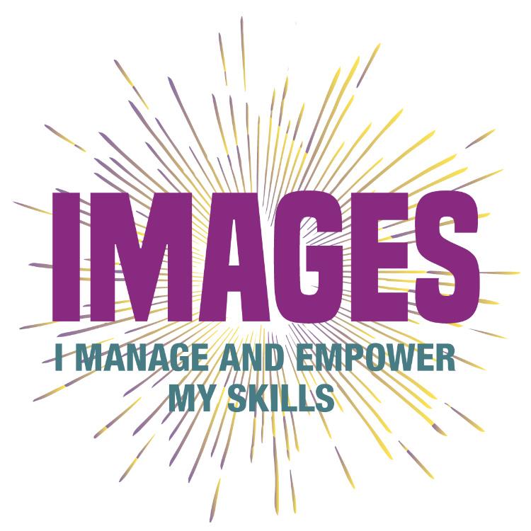
ABSTRACT
IMAGES is action research to promote a concrete tool able to define the constellation of competencies acquired in non-formal learning contexts of one of the key figures in the non for profit sector: the European Repertoire/ Profile of a Local Manager of a not-for-profit organization (NFP’s). Not all EU countries followed the recommendations and developed the specific professional profiles and qualifications for this sector. To profile these figures through our project it is considered innovative as it responds to a common European need: the lack of this profile in regional and national Repertoires. It is attested that the third sector is one of the economic areas that increase year by year at European level both in terms of GDP produced and by a number of employees. In this context, although volunteers are the backbone of this system, it is the local manager who play a fundamental role in terms of governance. Their work is divided between coordination of activities, management, administration but also impacts the bottom-up democratic processes, promoting participatory and economic democracy. The project aims to gather European good practices and start from them to encourage their transferability in other Countries and contribute to the construction of a European repertoire. In general, IMAGES aims to encourage the definition, identification and assessment of skills acquired through informal and non-formal learning and field experience, also thanks to the use of multimedia tools (such as Open Badges). The project also aims to propose a training opportunity based on massive Open Online Courses (MOOC) for Counselors, professionals who act as key figures for the identification and documentation to the recognition of skills. The publication and adoption of the IMAGES Repertoire by public bodies holding the system of validating competencies at the regional and national level, as well as by accredited private bodies, will lead to the achievement of the overall project objective. Furthermore supports a European framework and at the same time creates a dialogue at the national level that brings together the main stakeholders and policymakers on the same table, in order to coordinate the implementation of policies in the area of certification and to use part or all the results of our project. The project's activities are designed to be linked to a consequential process that leads to the expected results. It is a question of starting from the state-of-the-art validation process in this area through a comparative analysis to outline the European context (IO1). For this purpose, a common paradigm of theoretical definitions and references relating to general, specific and transversal skills acquired in non-formal learning contexts such as the non-profit sector will be identified. The research will continue with the identification of a sample of 72 managers as participants in focus groups and in-depth interviews, to identify analysis elements needed for the next phases of the project. In order to start the trial phase and produce 72 validation documents (IO3) it is necessary to identify counselors with specific expertise related to the Third Sector able to properly accompany participants in the identification of their skills. For this reason, the partnership will publish a MOOC (IO2) to provide specific training. Thanks to the presence of Roma Tre University it will be possible to reach the third phase of the European Guidelines for the validation of non-formal and informal learning Cedefop (2016) which provides the assessment and issuing the assessment document. The main expected result is to arrive at the definition of tools based on a scientific methodological approach to identify the skills that delineate an NFP’s manager operating locally. The project also aims to achieve the following: have promoted an innovative bottom-up methodological process through which it will be possible to give a voice to civil society in the EU's debates on the validation and acquire competencies and be complementary to the activities carried out by CEDEFOP, the Council and the European Commission; provide support to develop system reforms, such as the definition of lifelong learning strategies and national qualification frameworks. At EU level, we have partly encouraged the pursuit of the EU's objective of strengthening a key professional profile in the third sector and integrating EU instruments (e.g. EQF/EUROPASS) in a sector that is not yet fully developed

