Ipsos-Spf International Barometer on the perception
of poverty and economic precariousness

The European Barometer on Poverty and economic Precariousness has been carried out for the second year running, with a wider range of countries surveyed. The 6 European countries surveyed in 2022 were surveyed again this year: France, Germany, Greece, Italy, Poland and the United Kingdom. 4 new countries were surveyed this year: Portugal, Serbia, Romania and Moldova.

A total of 10,000 Europeans were questioned, representative of the national population aged 18 and over in each of the 10 countries surveyed. The survey was conducted online between 7 and 27 June 2023.

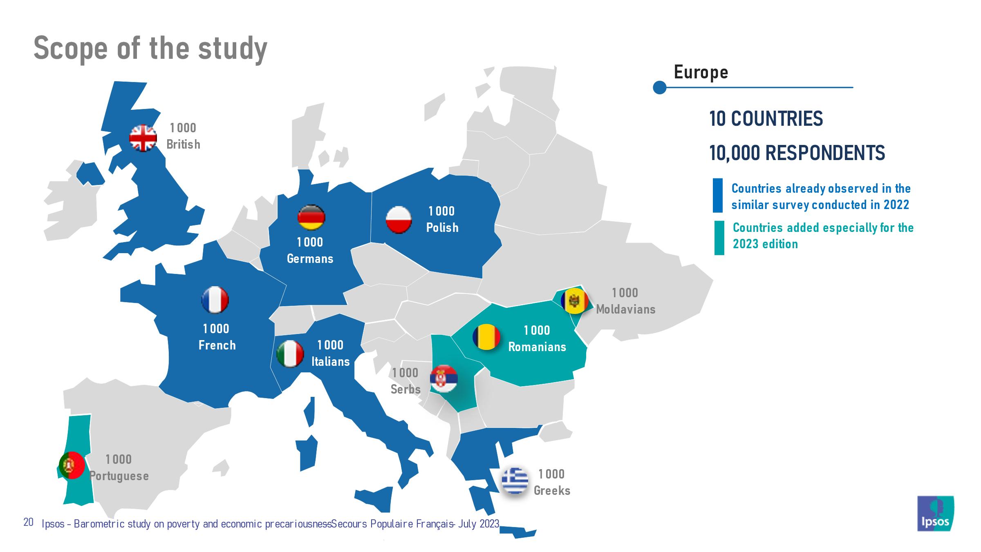

Across Europe, the situation is still very worrying

- The purchasing power situation of Europeans is still worrying in 2023. More than one in two Europeans surveyed say that their purchasing power has declined over the last three years (55%). This situation is particularly acute in Greece (64%), Serbia (63%) and France (60%) and get worst in Italy this year (59%, +2 points compared with 2022).

- This drop in purchasing power has a clearly identified cause. Of those who have experienced such a fall, 89% cite rising prices as the reason, well ahead of a fall in income linked to their activity (24%) or new expenses (23%).

- Against this very difficult backdrop of very sharp price rises in Europe since the start of 2022, almost a third of Europeans (29%) say they are currently in a precarious financial and material situation. While on a continental scale this proportion of people declaring themselves to be in a precarious situation is very worrying, the reality is particularly gloomy in Greece (49% declare themselves to be in a precarious situation) and Moldavia (46%), and the situation worsens in Italy (27%, +2 points compared with 2022). Apart from those in precarious situations, the majority of Europeans (56%) are getting by, but need to be careful, with only 15% claiming to be in a good situation.

- Europeans are concerned about the risk of falling into a precarious situation. Nearly one in two (48%) consider that there is a significant risk that they will find themselves in a precarious situation in the next few months. In the countries already surveyed in 2022, this figure has fallen this year, but remains very high, particularly in Italy (69%) and Greece (58%).

The vast majority of Europeans have already had to make complicated choices because of their financial situation.

- 80% of Europeans have already experienced at least one difficult situation because of their financial situation, and one in two (51%) has experienced at least one recently! People living in Moldavia (68%) and Greece (63%) are the most likely to have experienced such situations recently. However, even in Germany, where the proportion is lowest, 39% of respondents have experienced at least one of these situations in the last six months. In Italy, this rate reaches 44%.

- Among the most common situations, 62% have already had to restrict their travels (57% in Italy) and 46% have not turned up the heating at home when they were cold (43% in Italy). Even more worryingly, almost one in 3 Europeans (30%) has skipped a meal when hungry (23% in Italy, +5 points compared with 2022). This figure is particularly high in Greece and Moldavia (38% and 37%).

- These difficult situations also affect parents. More than a third of European parents (36%) have already been in a situation where they could not provide for their children's basic needs, with almost one in five (17%) having experienced this situation in the last six months.

In the face of inflation, the need to adopt certain behaviours

Over the last two years, these difficult situations have become more frequent, and many Europeans are forced to adopt certain strategies in order to cope with inflation and falling purchasing power.
- The most common behaviours are looking for low prices (85% do so) and frequenting hard discounters (70%). But some more serious situations affect many people: 38% no longer eat three meals a day! And 31% of parents skip meals despite hunger in order to feed their children (24% in Italy).

- Although 64% of currently employed Europeans have an income that covers all their expenses, this is not the case for more than a third (36%) of them (31% in Italy). The situation of working people is therefore very worrying, particularly in Portugal and Serbia where this difficulty affects one working person in two. Having a job does not necessarily mean being able to get by financially.

Although inflation is slowly decreasing, it still remains a source of concern for many

- Although inflation has begun to fall and is causing slightly less concern than in 2022 in most European, it still remains a threat for many households. Thus, 62% of Europeans say they are worried about their ability to cope with inflation on food prices, 59% about a possible unexpected expense and 59% about an increase in the price of gas. Working Italians are particularly worried about finding another job if they lose theirs (61% versus 52% of working Europeans surveyed).

- In most countries, more than half of those questioned said they were worried about these possibilities. Greek respondents, as in 2022, are particularly worried about their ability to cope financially.

Europeans are ready to get involved to help others!

- Against this difficult backdrop of inflation and deprivation for many Europeans, the majority of people surveyed say they are prepared to get personally involved in helping people experiencing poverty. 76% say they could do so, a figure that is particularly high in the countries where reported social difficulties are most common: Greece (84%), Portugal (84%) and Serbia (84%).

